Software development: Mandarin group
Documentation: The report should explain how the software is structured and how it works. It should outline the overall design philosophy, then go on to explain the technologies that were used to develop the software – why these were chosen and how they were used. Limitations of the software and opportunities for future development should also be explored. There is no specific word or page limit, but a document of around 10-20 pages is likely to be sufficient.
Introduction
This documentation describes the structure and design of the BioInformatics Mandarin Software developed during the BioInformatics Software group project course 2017-18 at Queen Mary University, London (U.K.). The Mandarin software was developed to allow analysis of RNA or DNA data in FASTA format. The software allows a BLAST search of the data input from the user, and statitistical analysis with R-packages producing different types of graphical analyses such as Volcano plot, dendogram, and Heatmaps, and tables.
The aim of the documents is to describe the structure and design of the Mandarin Sowftware in the way that create interest, and concerns of future stakeholders. We understand stakeholders as:
- Users and customer that need to be assure that the structure will provide system functionability, and also include non-functional requirements such as reliability, and future upgrades.
- Developers that desire a simple and efficient system to minimize the complexity, and development effort.
- Maintenance Programmers that will like to be assure that the programs is easy to update and maintain in the future.
Technologies Use
In order to develop this software the Mandarin group have used Flask. What is Flask? Flask is defined as a microframework that uses the Python computer language. It was developed by Armin Ronacher. Flask is based on the Werkzeug toolkit, and Jinja2 template engine. The routing, debugging and Web Server Gateway Interface (WSGI) are provide by Werkzeug and the template support comes from Jinja2. Figure 1 shows a basic Flask structure.
From flask import Flask
app=Flask(__name__)
@app.route(‘/’)
def index():
return ‘X’
if __name__==’__main’:
app.run(debug=True)

Figure 1. Showing the main feature of a Flask based website.
from flask import Flask
app=Flask(__name__)

Figure 2. Show the first statement of a Flask based website.
This first statement of the structure creates an application instance, which is an object of class Flask. This imports the Flask library and creates a new website in the variable ‘app’ (Figure 2). The second statement of the application is the route and view function. Through the route function the application knows the code required to run each URL request. Flask does this by mapping the URLs to the Python function The Python def index() is called a view function, and works as a handler for the application root URL, the return value of this function is called the response, and that is what will the user will see (Figure 3).
@app.route(‘/’)
def index():
return<h1>X<h1>

Figure 3. A simple representation of the app.route decorator, which register the decorated function as a route. It can has as many decorators as the website requires.
The last statement of a Flask based website is the server startup. The first line of the statement ensure that the application runs when the scripts is executed directly. During the development of a website it is advisable to enable the debug mode, which activates the debugger, and reloader (Figure 4).
if __name__==’__main__’:
app.run(debug=True)

Figure 4. Showing the last statement of the Flask based website that will initiate the application.

Software Description, and Functionality
The software developed for this tasks is folder structure according to figure 5. All these are sub-folders within the FlaskApp folder. The main folder, FlaskApp, contains the python codes to run this application, and analyse data.

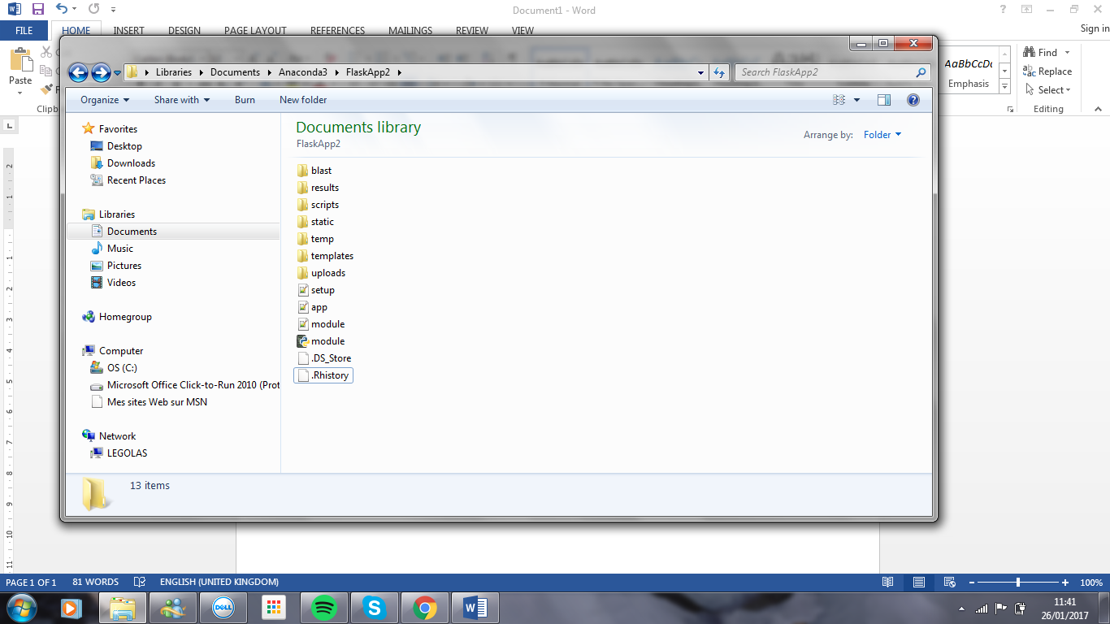
Figure 5. Showing the principal structure of the “ ”. Showing the 7 main folders, and python files needed to run the software.
Description of sub-folders
- Blast sub-folder; this folder stores the blast generate FASTA files.
- Results sub-folder; this folder stores the tables obtained from the R-analysis..
- Scripts sub-folder;
- Static sub-folder; this folder stores static files such as background pictures, and graphs obtained from R plots such as Volcano, Heatmap, and dendogram.
- Temp sub-folder; this folder holds temporary files containing information while a new file is being made.
- Template sub-folder; this folder store templates such as html files.
- Upload sub-folder;

How the Mandarin software works
The application is run through the app.py file. This file consist of 6 function:
- def allow_file(filename); checks if the file to be uploaded are of the allow type (see script in Appendix 1)
- def main(); this send a Ajax request. Ajax is a client-side script that communicates to and from a server/database without the need for a postback or a complete page refresh.
- def choose(); this communicate with the upload.htm, and allow to select the file to be uploaded.
- def upload(); this function has different functionalities such as:
  - checking if the selected files belong to the file extension allowed
  - make files safe, and remover unsupported chars
  - move files from the temp folder to the upload folder
  - save files into a list, redirect the user to uploaded file
  - redirect the user to the uploaded_file route showing the the files on the browser
  - load a htm page with a ling to each uploaded file
- def analyse(); will direct the files to a blast search, and R-analysis.
- def uploaded_file

